
IDBI APIM Platform

WebMethods External API Gateway Installation and Setup Guide

Software AG

Product Installation:

Login as user.
Copy installer, product image, license file to a common location. Here it is copied to /u01/binaries

Execute installaer as below:

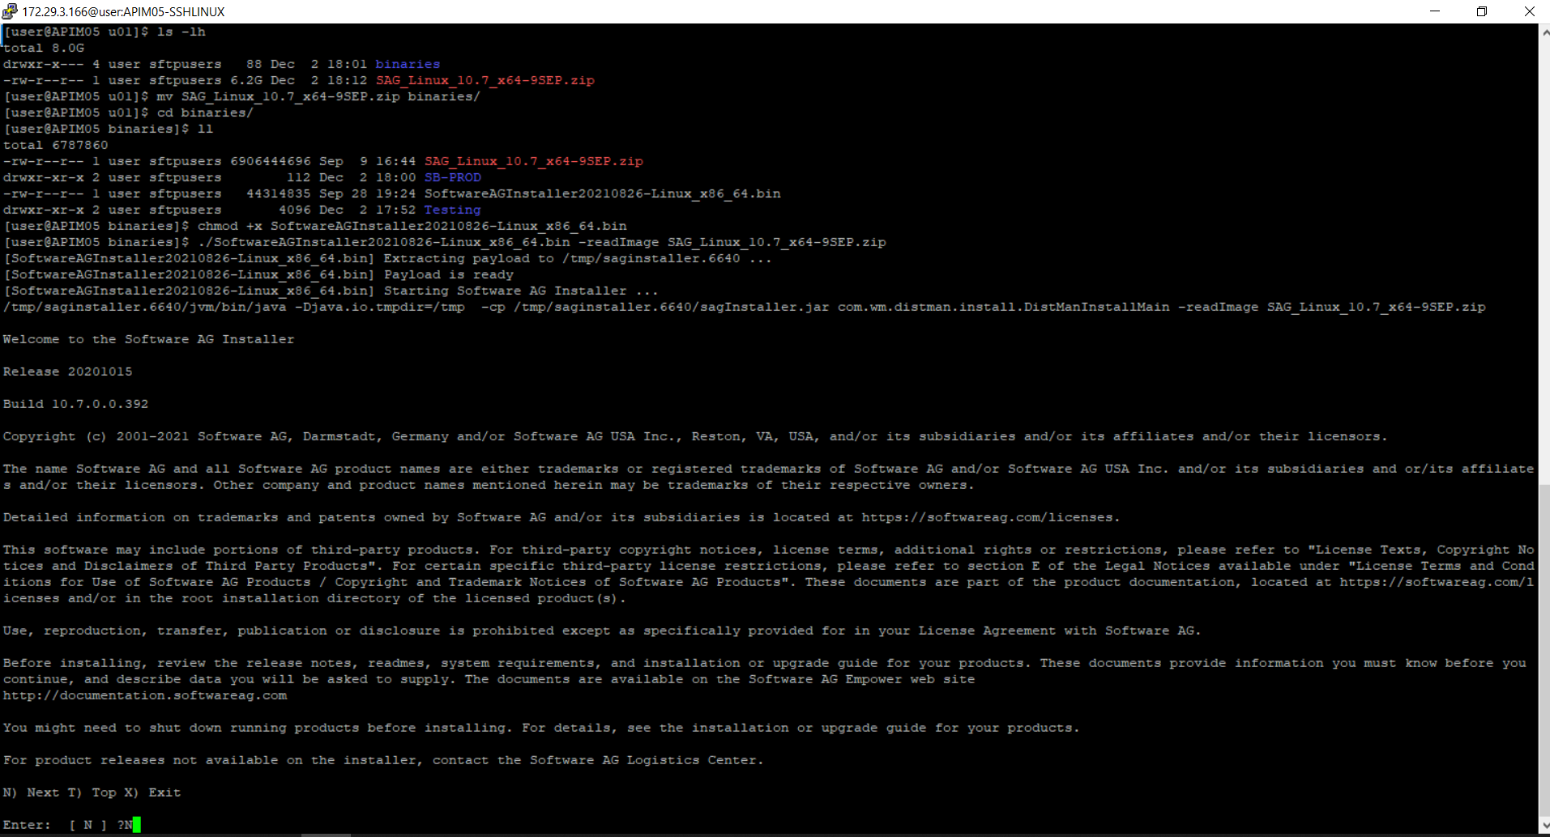
Give Directory Name for installation:
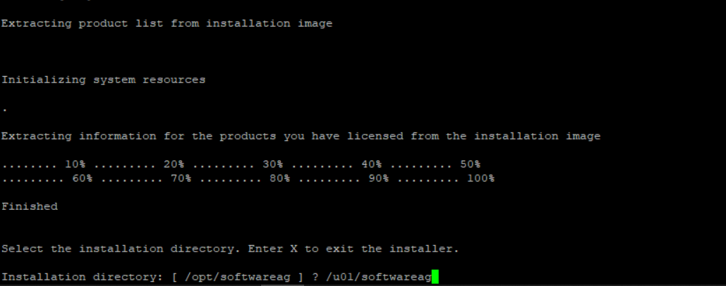
Give default values for hostname:
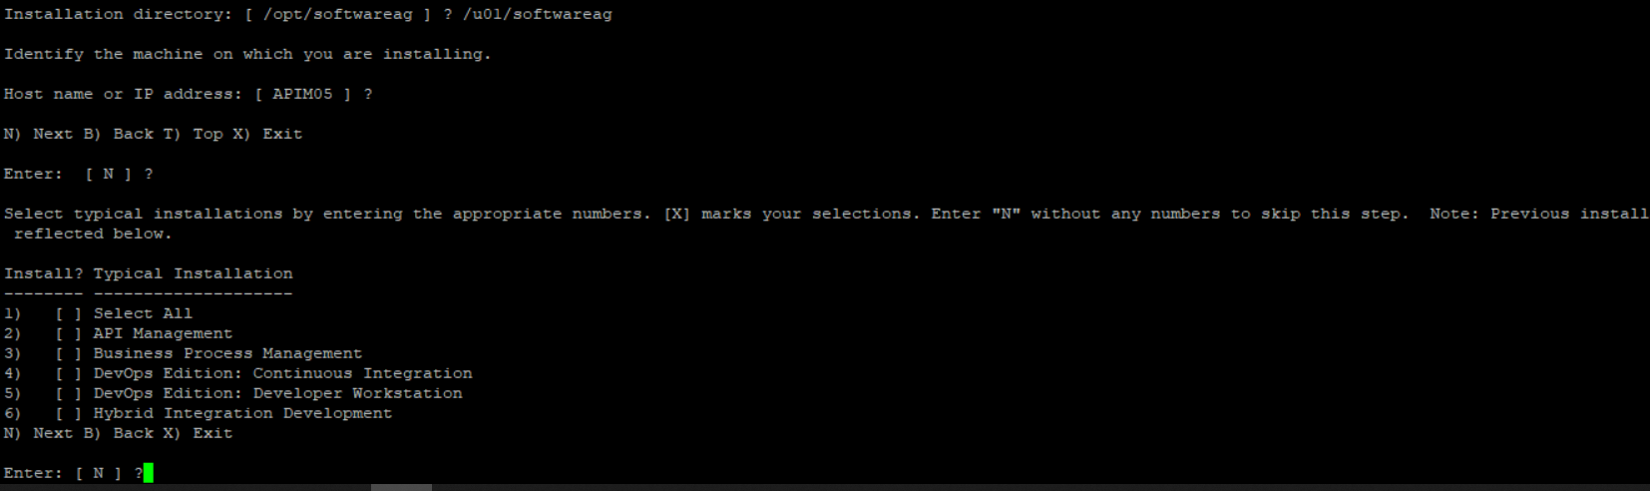
Press default N value while selecting product name to move to next screen. Later press + to go to next page. Then select 11 for installing API GW.
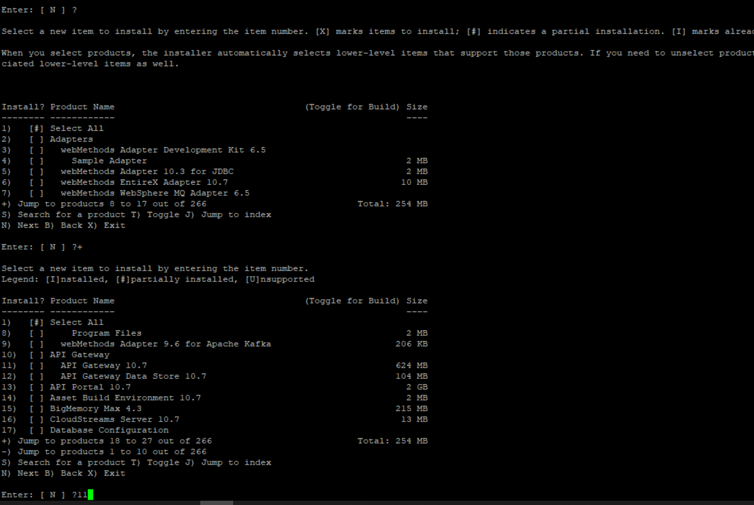
It will automatically select and display required components. Press Yes.
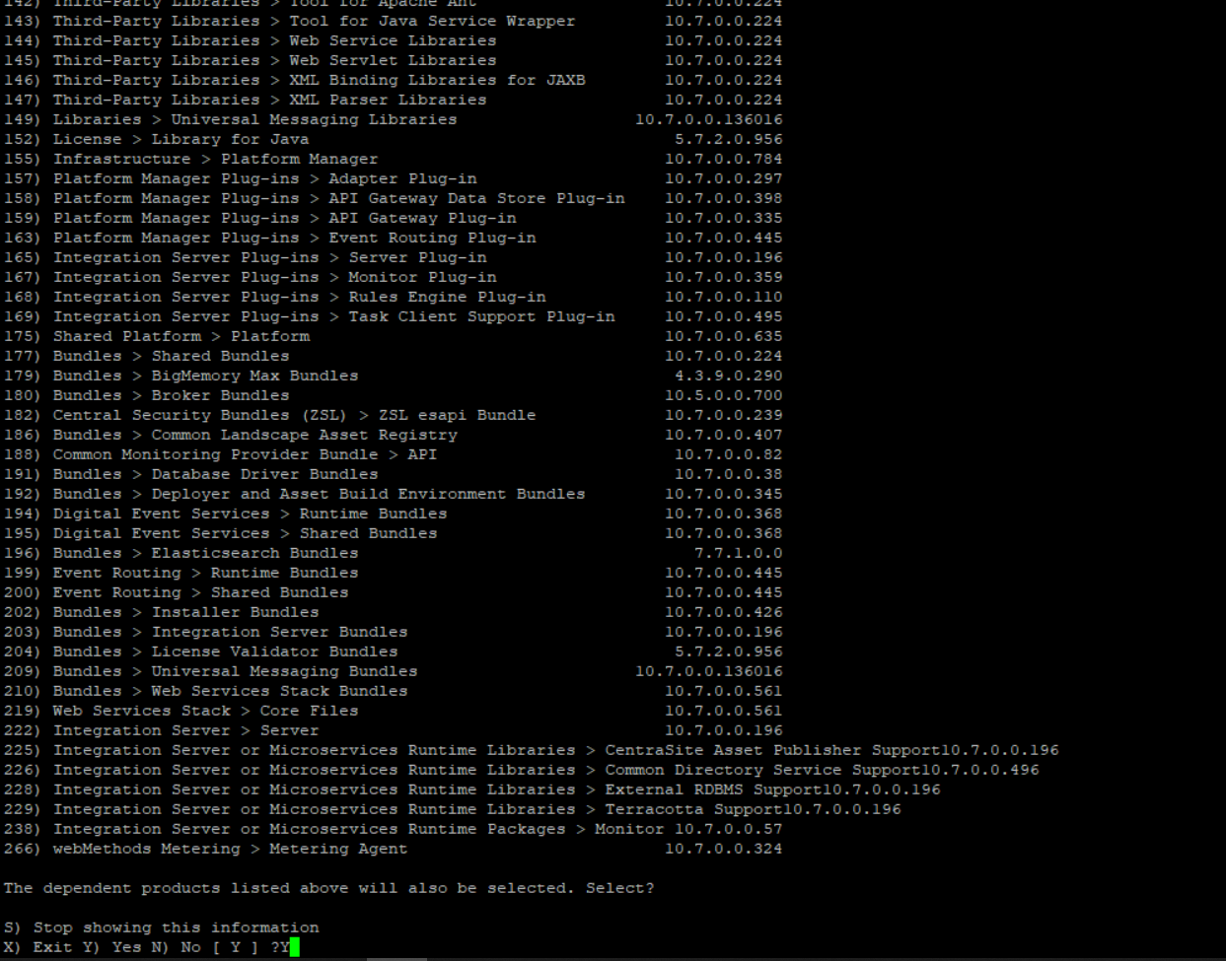

Press N to complete.
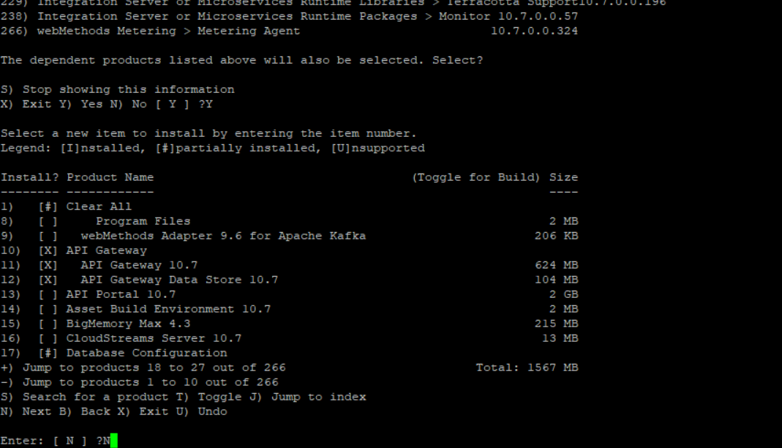
Press N to proceed with installing selected products:
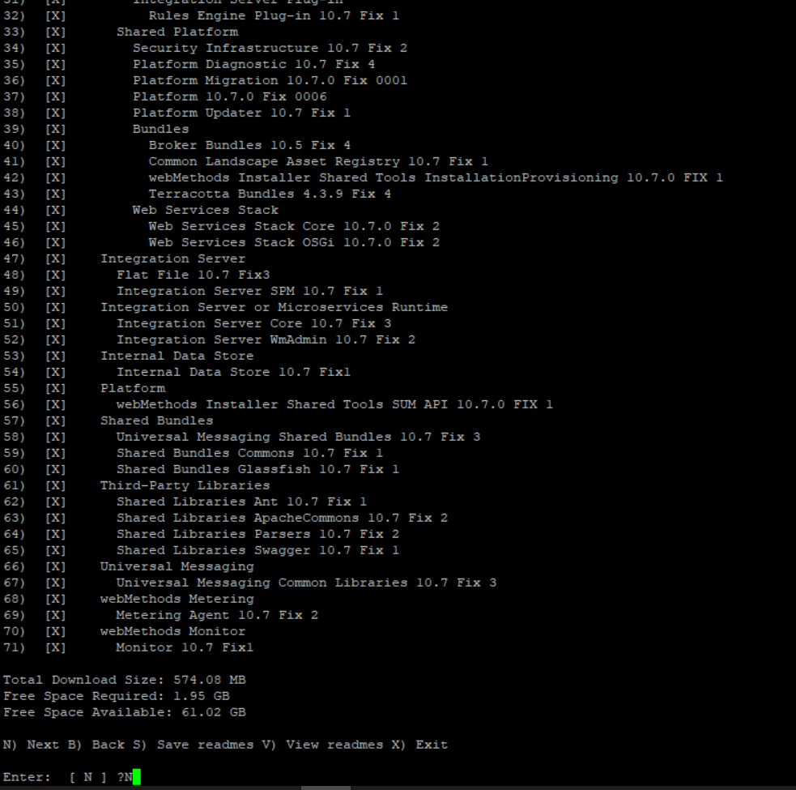

Read and accept license conditions.

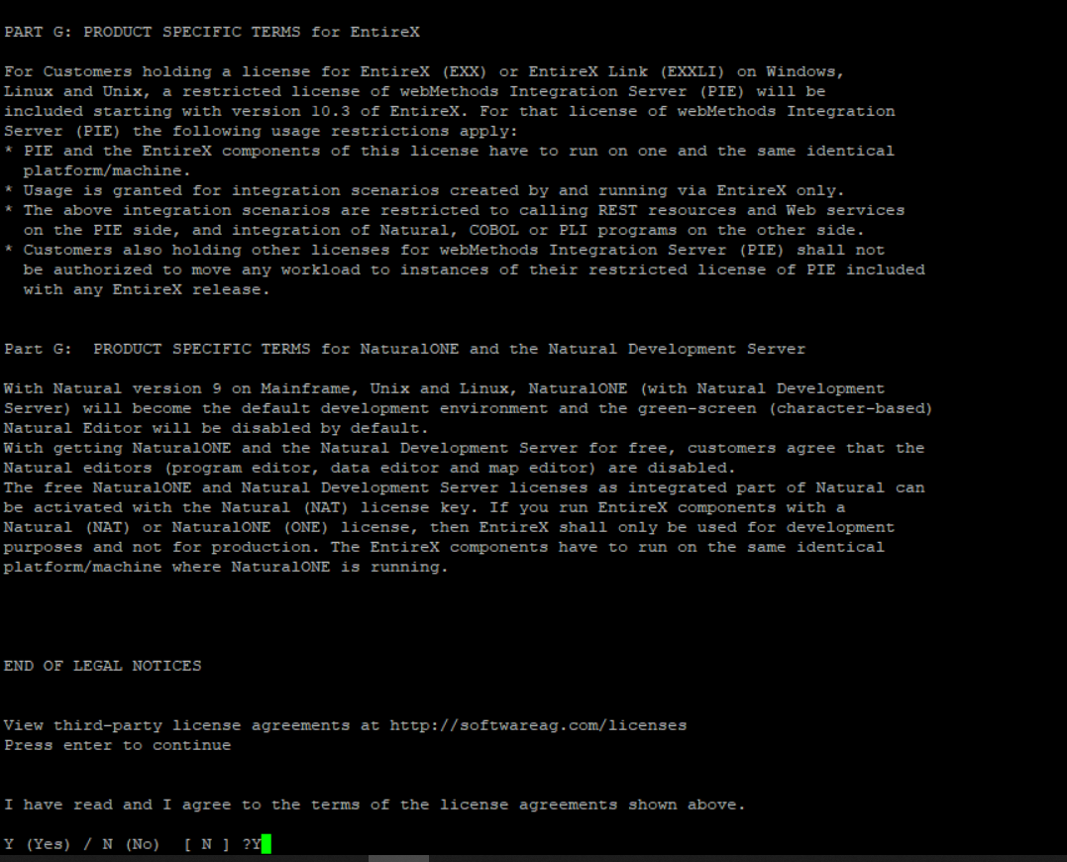
Press No for sudo access as 'user' doesnt have sudo priviliges.

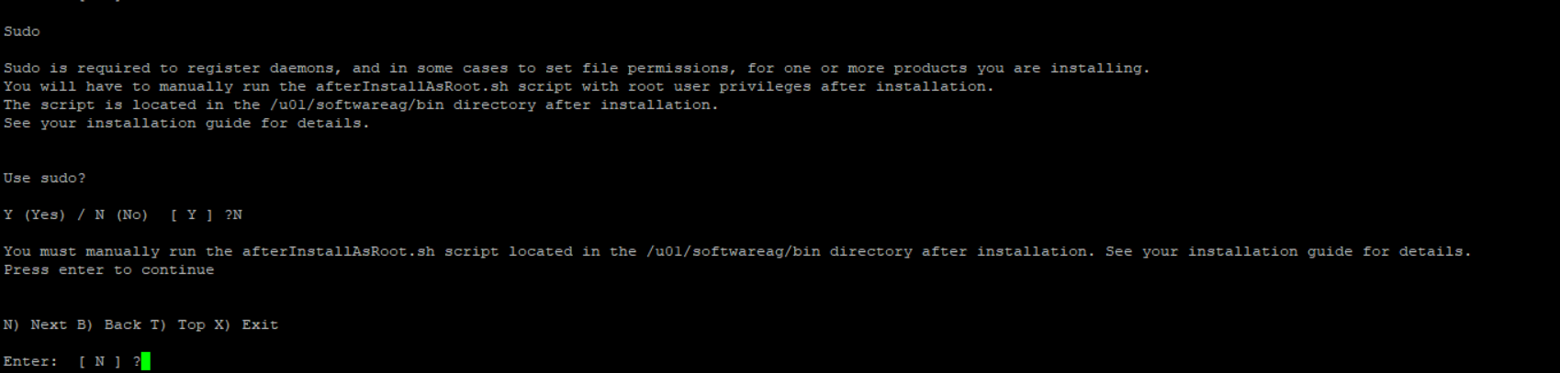
Give license file path and port numbers in next screen
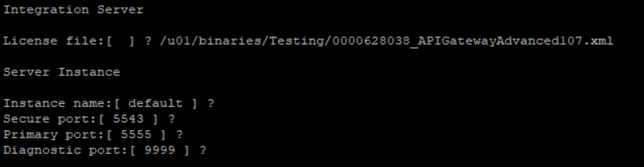

Register as Unix daemon

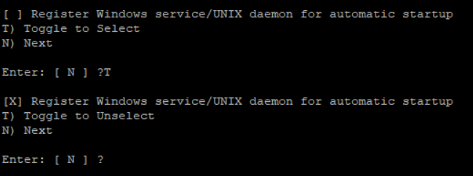

Default value for network interfaces:
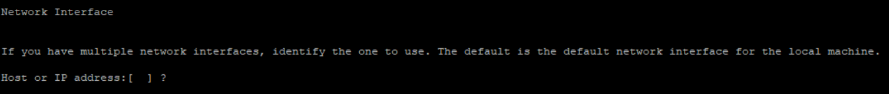
Install packages and embedded database
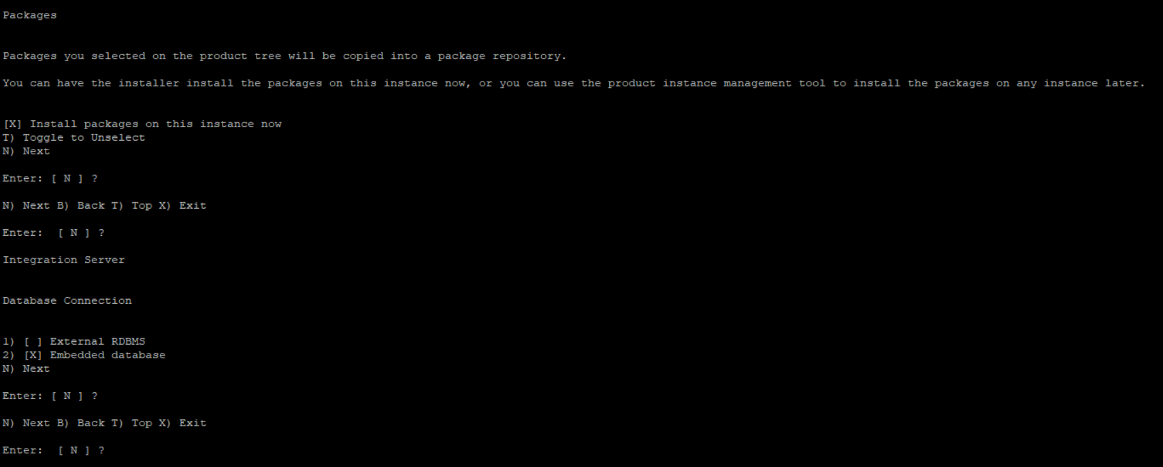
Swap http & https API GW ports:
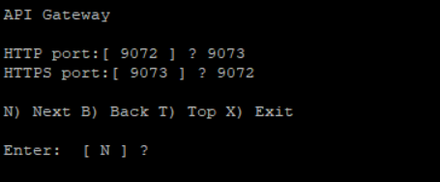

Platform manager setting:
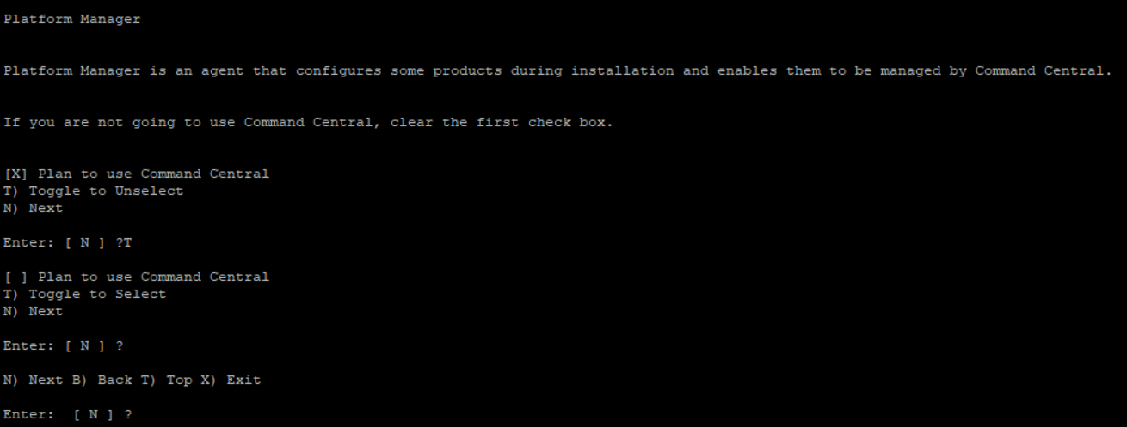

Datastore setup:
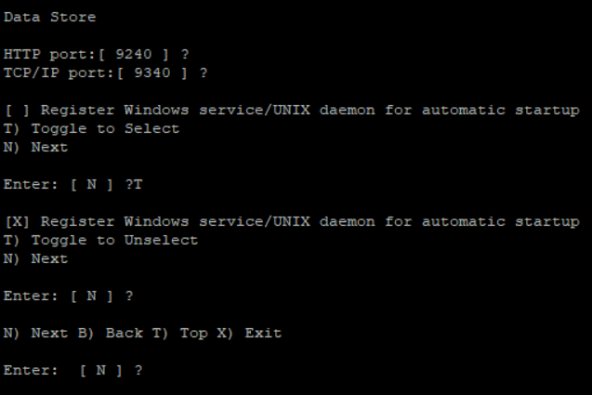
CDS Setup: Leave default values:

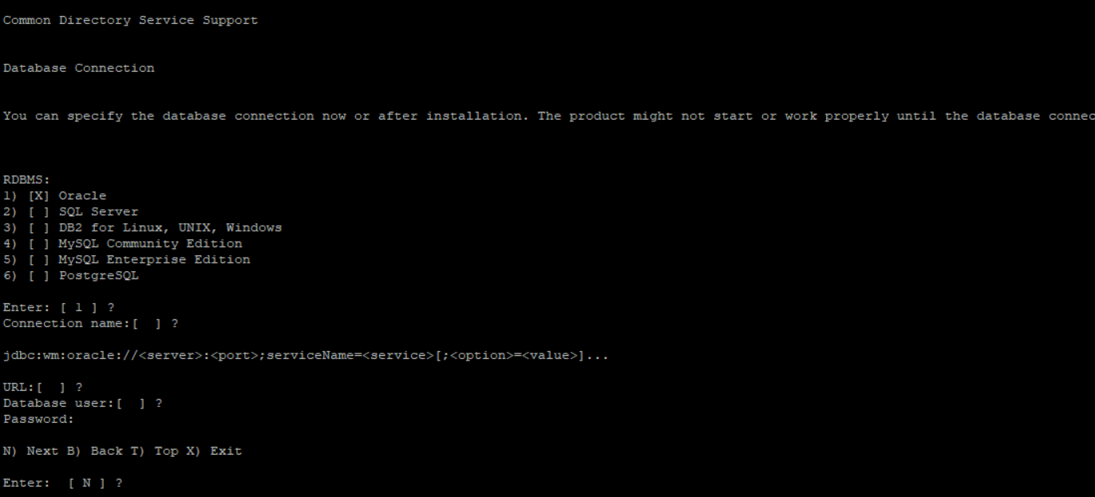

Final confirmation before installation:
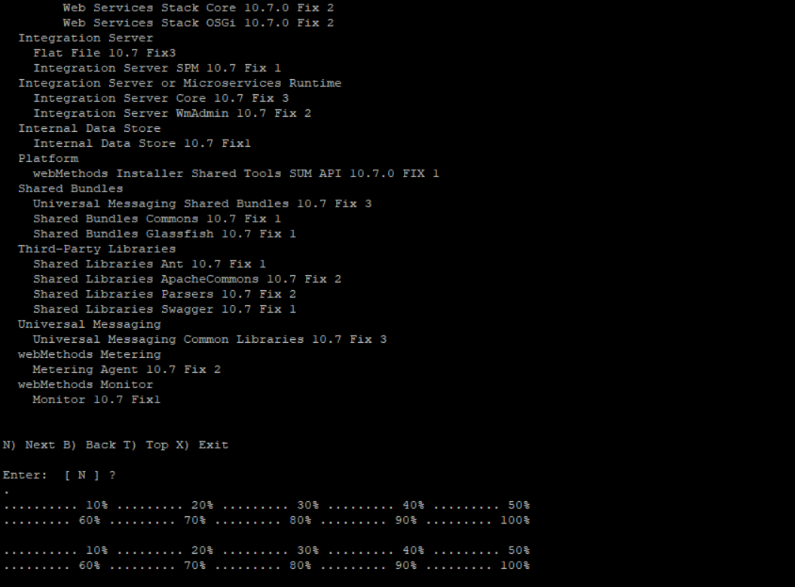
Product and Updates will now be installed.

View Summary and finish installation:
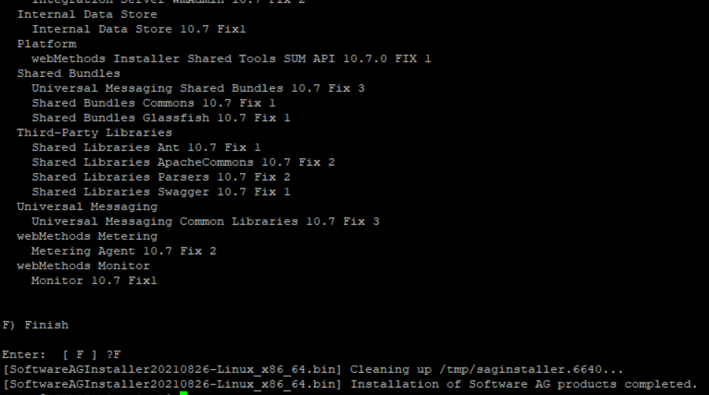

Login as root
Execute: /u01/softwareag/bin/afterInstallAsRoot.sh

OS Level Settings:
Login as root

Edit /etc/sysctl.conf and add “vm.max_map_count=262144” at the end of the file.

Edit /etc/hosts file to be able to resolve the hostname of the machine to 127.0.0.1

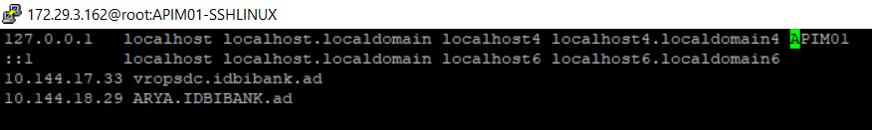
Reboot VM.

API GW Settings:
Login to 5543 port of IS and Navigate to API GW UI.
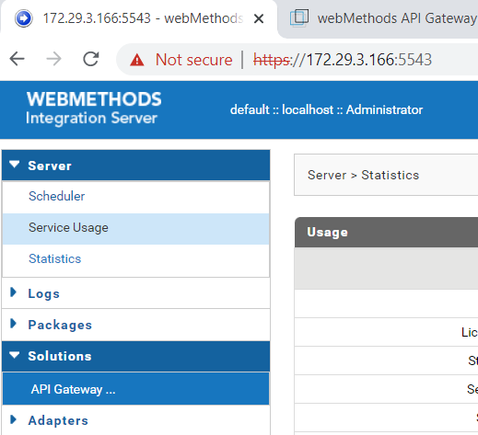

In API GW, Go to Administration
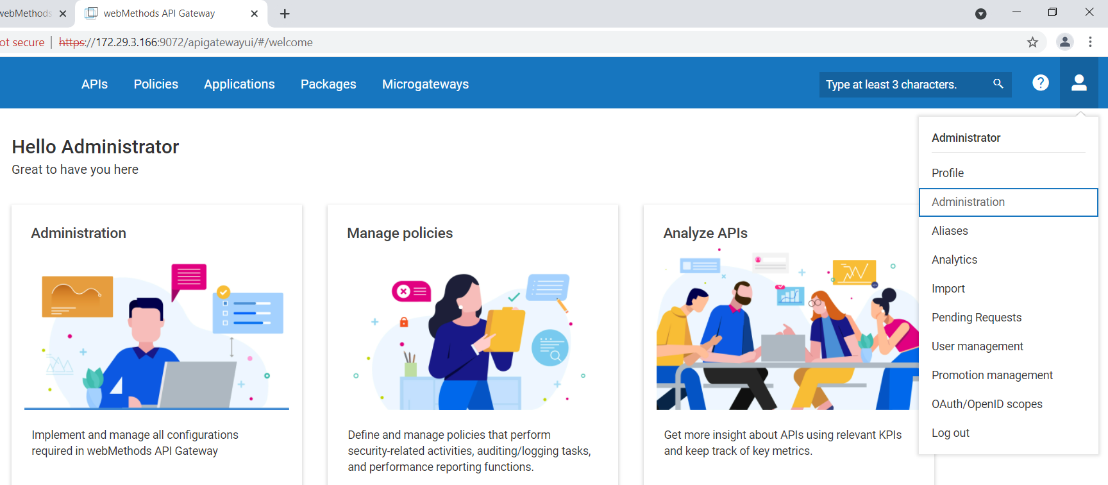

Adding Keystore and Truststore
Navigate to Security > KeyStore & Truststore. Add Keystore and Truststore:

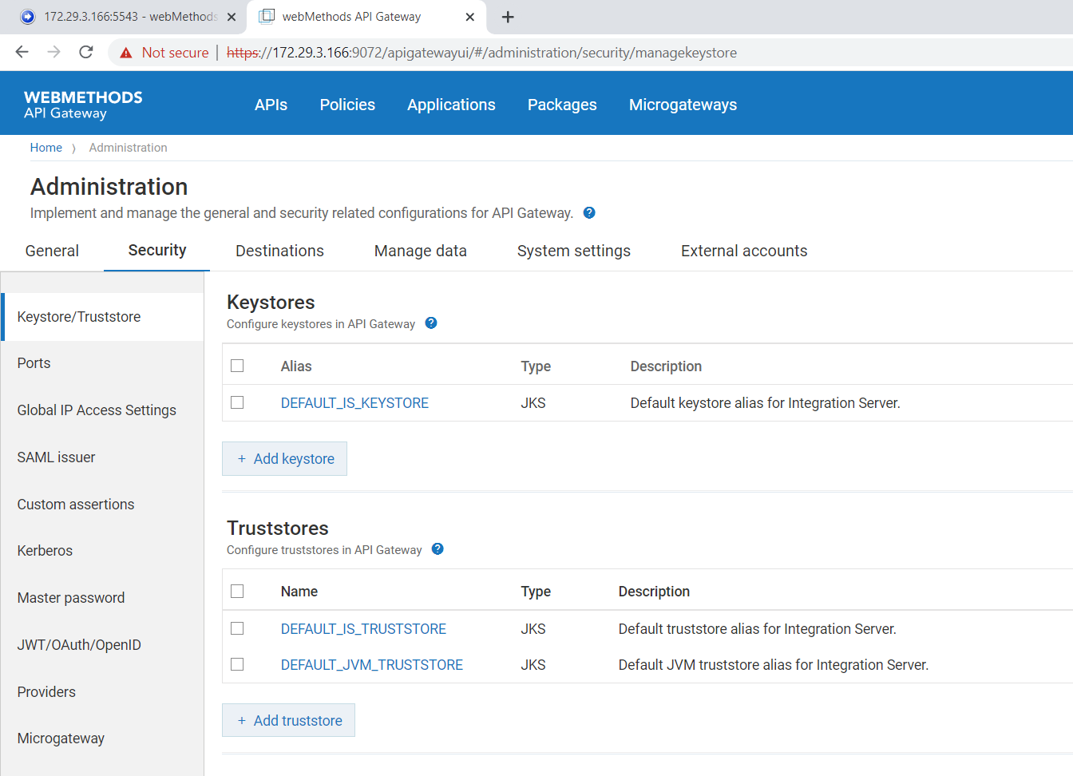
Post changes:
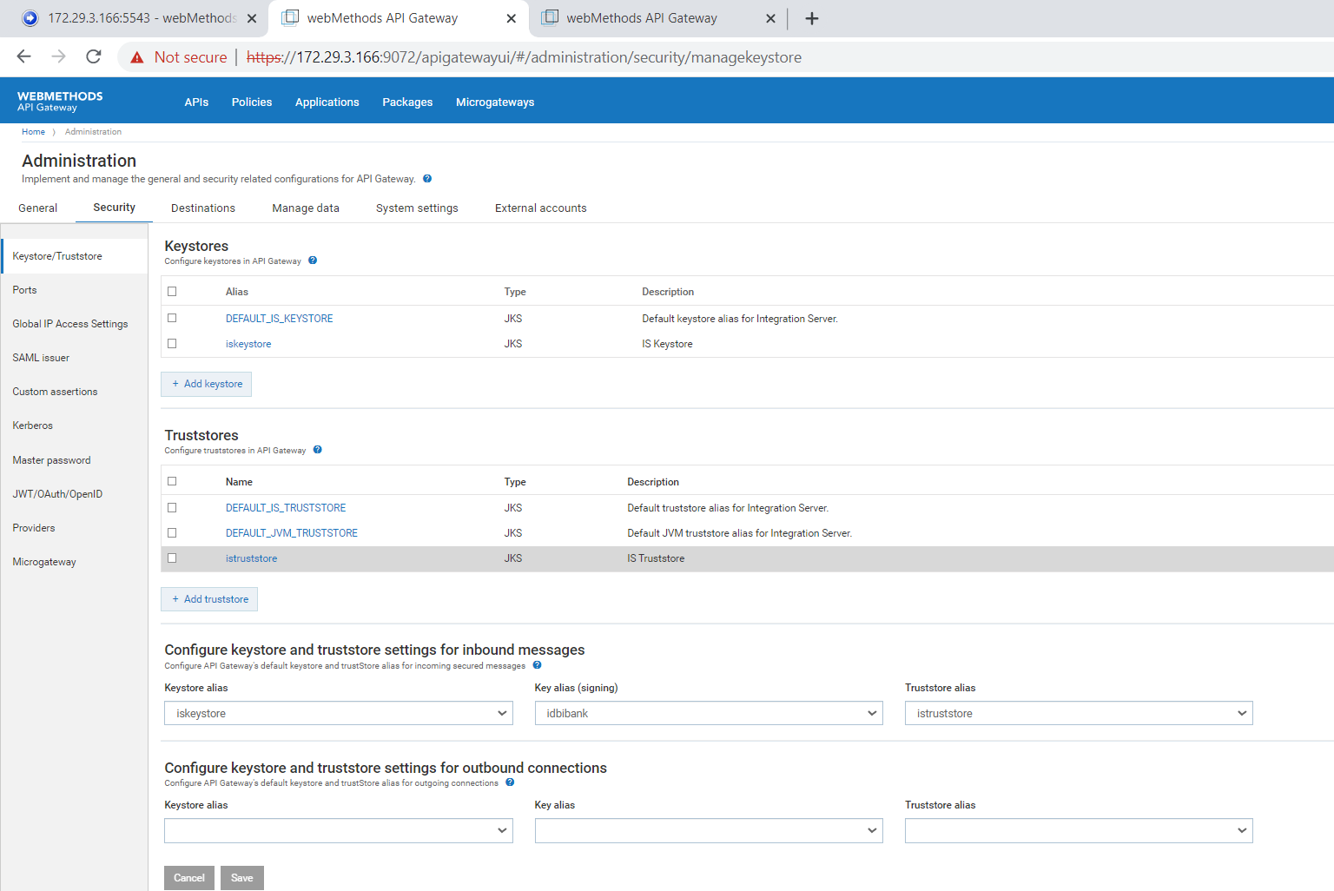

Convert Admin Port to https:
Navigate to Security > Ports.
Change Primary port to 5543 temporarily
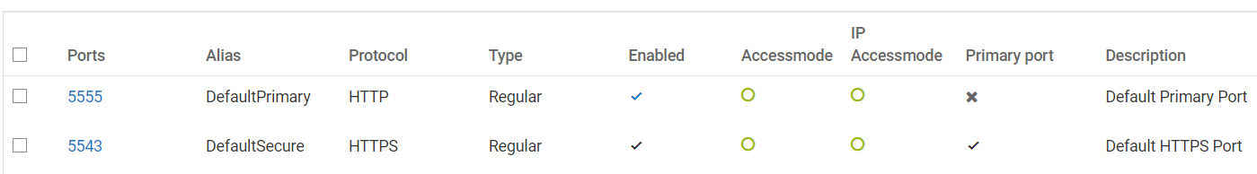

Delete Port 5555. Add https port 5555 with below settings.
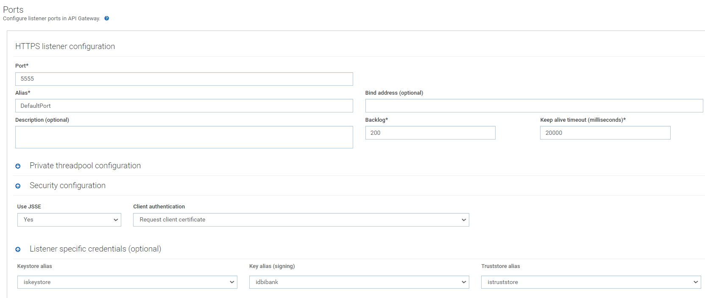
Allow access mode for 5555 to “Allow by Default”

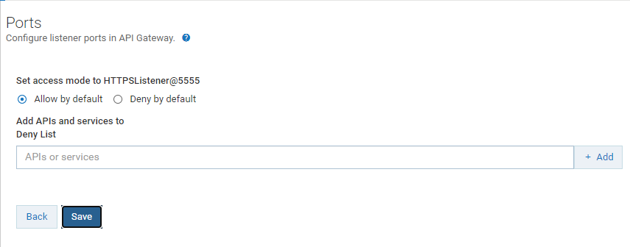

Enable Port 5555, change it to Primary Port
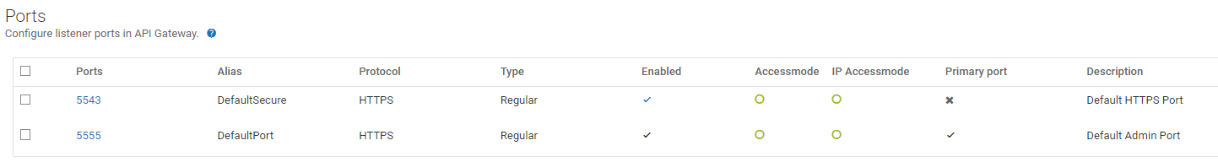

Adding Gateway Registration Port:
Disable and delete 5543 Port.
Go to Add new Port screen and select 'API Gateway External'. Add port 5543 and 6643 with details as below:
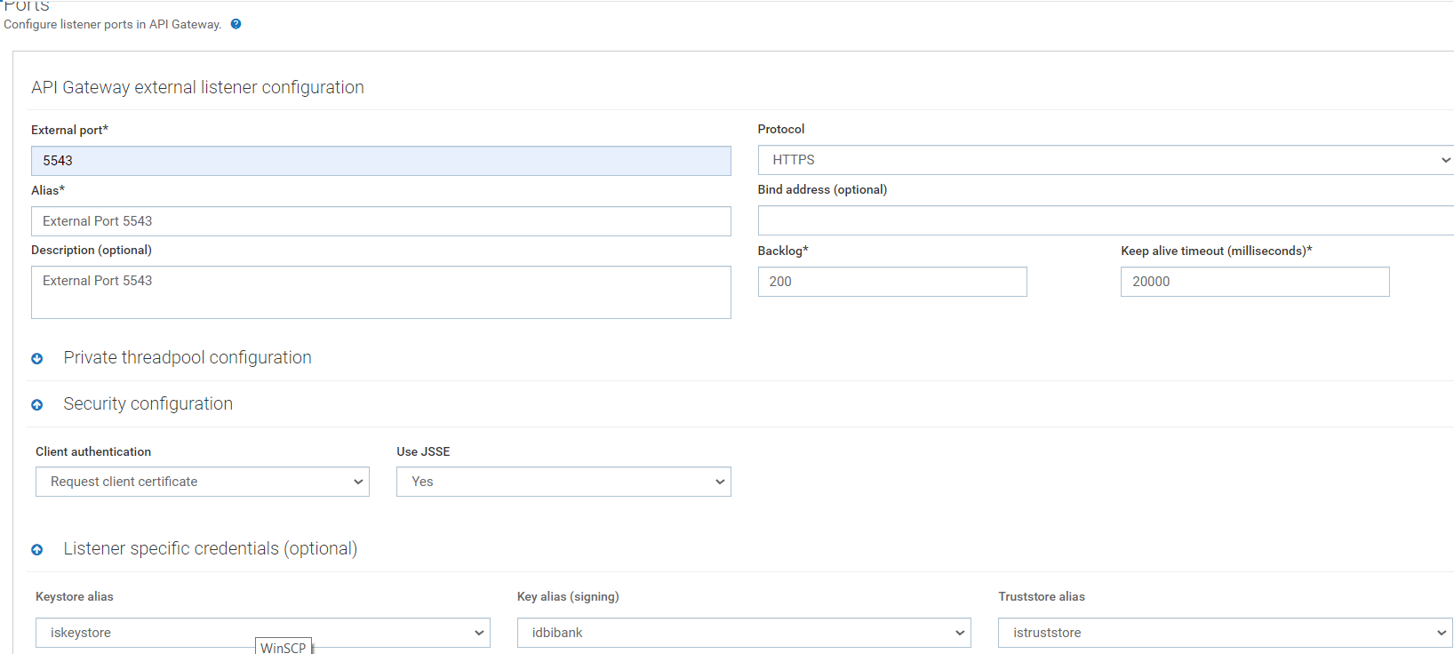
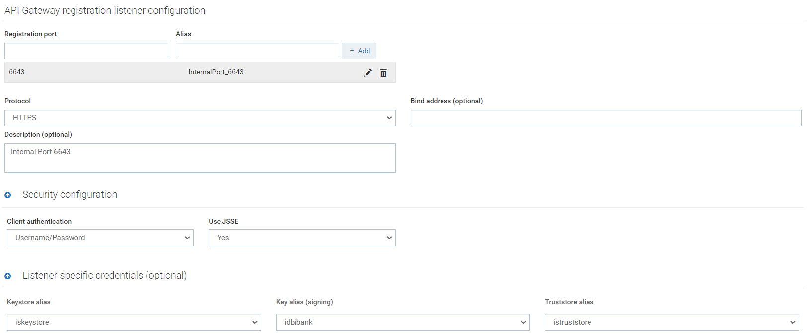
Enable both internal and external registration Ports:
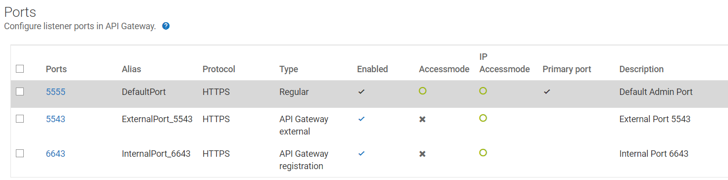

Changing Diagnostic port to https:
Login to IS Admin Page.
Navigate to Security > Ports.
Disable existing diagnostic port 9999 and delete it.
Click Add Port > HTTPS Diagnostic Port > Submit. Enter below details.
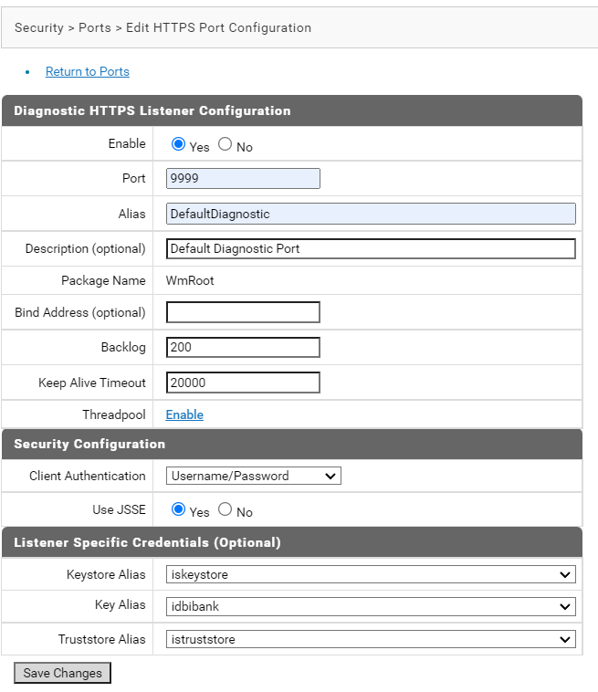
Change access mode to Allow by Default.
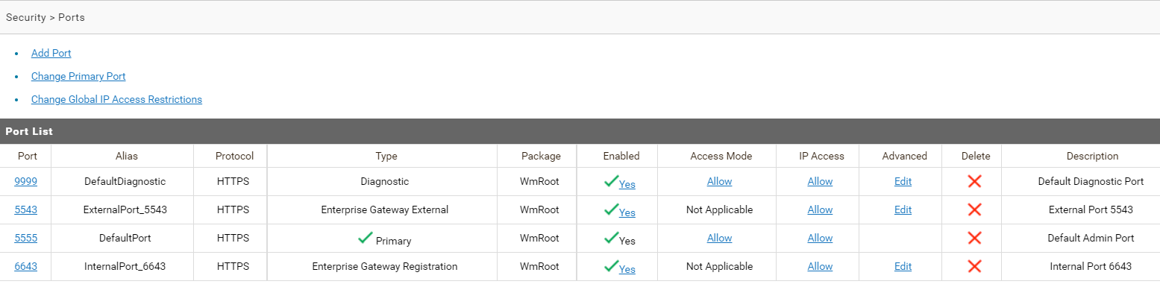

Changing Certificates on API GW Port:
Login to OS level with user 'user'.
Navigate to: /u01/softwareag/profiles/IS_default/configuration/com.softwareag.platform.config.propsloader/
Backup file: com.softwareag.catalina.connector.https.pid-apigateway.properties
[user@APIM05 com.softwareag.platform.config.propsloader]$ cp com.softwareag.catalina.connector.https.pid-apigateway.properties com.softwareag.catalina.connector.https.pid-apigateway.properties.bkup

Edit file to do below changes to update keystore and its password.
Note: Password needs to be entered in plain text. Next time APIGW is restarted, it will automatically change to a key and mask the password.

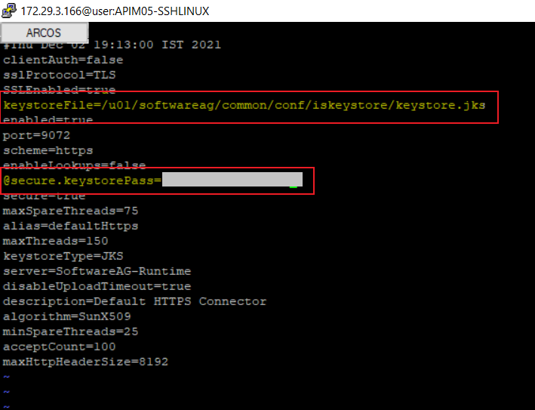

Restart IS/APIGW to take effect.
Verify Certificates now provided while accessing APIGW Admin Page (9072).

Change Admin Password:

Log in APIGW Administratoin Page. Navigate to Profile.
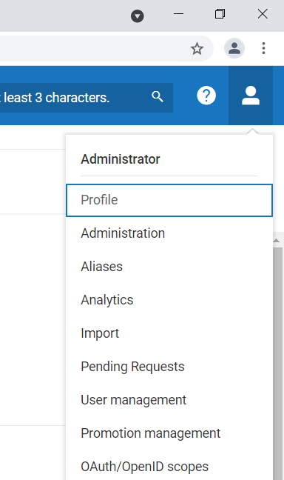
Change Password in Profile by giving old and new Password and save. Logout and Login to verify.

